AI-Powered Job Recommendation System

Priya Nahal
Department of Computer Engineering
San Diego State University
San Diego, CA
pnahal6545@sdsu.edu

Abstract—People are constantly in need of jobs and sometimes it can be hard to land a job in this market. Targeted AI job recommendations can help with finding jobs that match a person’s skill and experience.
Keywords—similarity search, recommendation, AI, jobs, machine learning, database

Introduction
This project is about an AI-powered job recommendation system. Traditional job recommendation systems can be less accurate as they use keyword matching and can’t understand semantic similarity between words. A job recommendation system that uses AI can help with this as it can understand semantic meaning and can recommend the right jobs even if the terminology is different. The objective of this project is to have users upload their resume and extract the text, job titles, and skills from it. Then these are used to gather jobs from different APIs and get the semantic similarity scores. This is further improved by using an overall similarity score which takes into consideration the semantic similarity, job titles, and skills. Users will receive their scores and missing skills analysis for each job posting.

Related Work

Other Job Recommendation Systems
By looking at a user’s search history and activity, traditional job recommendation systems such as LinkedIn, Indeed, Glassdoor, etc. return job suggestions. LinkedIn works by using the search bar to match keywords by describing the kind of job the user is looking for. Users can also add filters when searching and add their job preferences in their profile. Indeed allows users to upload their resume and add their job search preferences. Glassdoor finds jobs with its job search tool and filters such as location, date posted, salary range, etc.

Semantic Similarity Search

Sentence Transformers (SBERT) is a modification of the standard BERT network and is used to make embeddings (fixed-size repersentations) from text, images, video, or audio and it is then used to calcaulate similarity scores. Cosine similarity is one such metric used to compute how similar two things are by looking at the cosine angle. Specifically, looking at which direction two data points point to, it can be very helpful in comparing similarity in high-dimensional spaces. Facebook AI Similarity Search (FAISS) is used for faster similarity search and putting a collection of data points into a group with the same attributes. It finds the closest vectors first using the Euclidean distance.

Technical Details

Tools
For the frontend, React and CSS are used to design it. Different functionalities such as user authentication, uploading resumes, pagination, navigation, and API requests were done. To develop the backend Django, the Django REST Framework, and python were used. Django was used to manage the resume being processed, jobs getting recommended, managing the database, and overall functionality. The Django REST Framework was used for user registration, managing resumes, and saved jobs. Python was used to implement all the machine learning parts such as embedding, cosine calculations, and FAISS.
The database used is PostgreSQL which stores all the information such as resumes, recommended jobs, saved jobs, and user accounts. Sentence-BERT was used to get embeddings for the resume text, job titles, and skills which will be compared using cosine similarity. Cosine similarity uses a mathematical formula to calculate the similarity between two vectors. FAISS was used to get faster similarity searches, and it did this by retrieving the vectors that are nearby, this was how they got ranked. To gather jobs, APIs such as Adzuna, USAJobs, and JSearch were used. Duplicate postings are deleted and then the jobs are recommended to users.

System Architecture
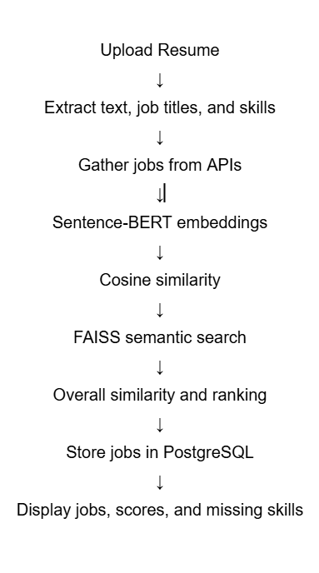
Fig. 1. System architecture of recommendation system.

User Features
Fig. 2 shows the profile page where users can see their name, username, and email address. They are also able to change their password by entering the current and new one.
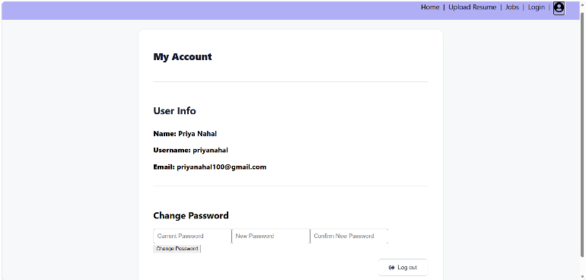
Fig. 2. Profile page.

Upload Resume

Fig. 3 shows the upload resume page which asks users to upload a pdf or docx file. Then the resume text, job titles, and skills are extracted and the page navigates to the job recommendation page. The previous history of all the resumes is shown and users can choose to select an old resume.
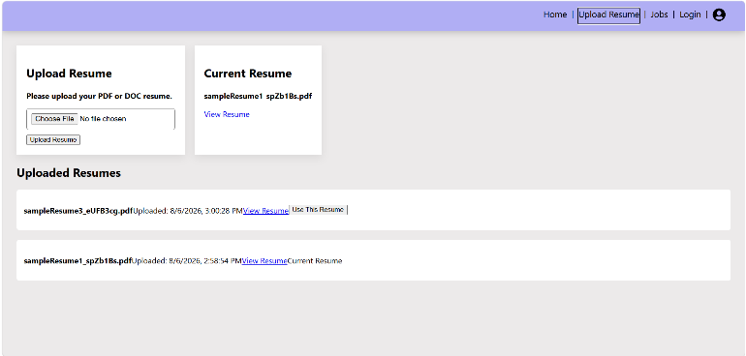
Fig. 3. Upload resume page.

Job Recommendations
Fig. 4 is showing the job recommendations page. Users can choose to ‘Apply Now’, save the job or click on the ‘View More’ link to get more information.
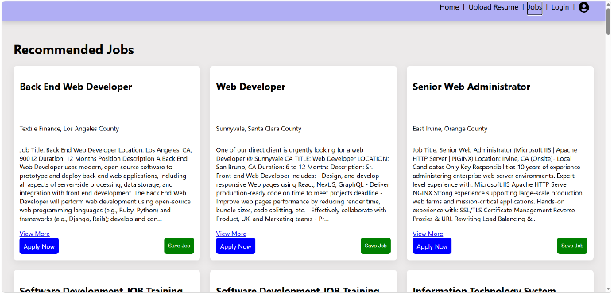
Fig. 4. Job recommendations page.
Fig. 5. Shows the home page where the saved jobs are displayed. Users can choose to keep the job there, remove it, or apply for it.
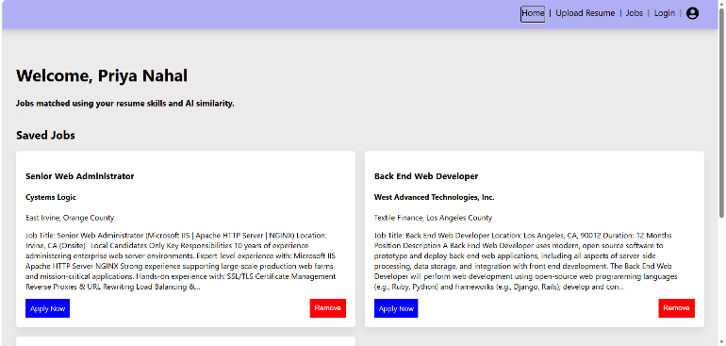
Fig. 5. Home page

Display Results
Fig. 6 and Fig. 7 show what happens when we click on the ‘View More’ link. We can see the semantic similarity, job title, skill, and overall match score of the user’s resume and that job. The skills the user is missing for that specific job are also shown.
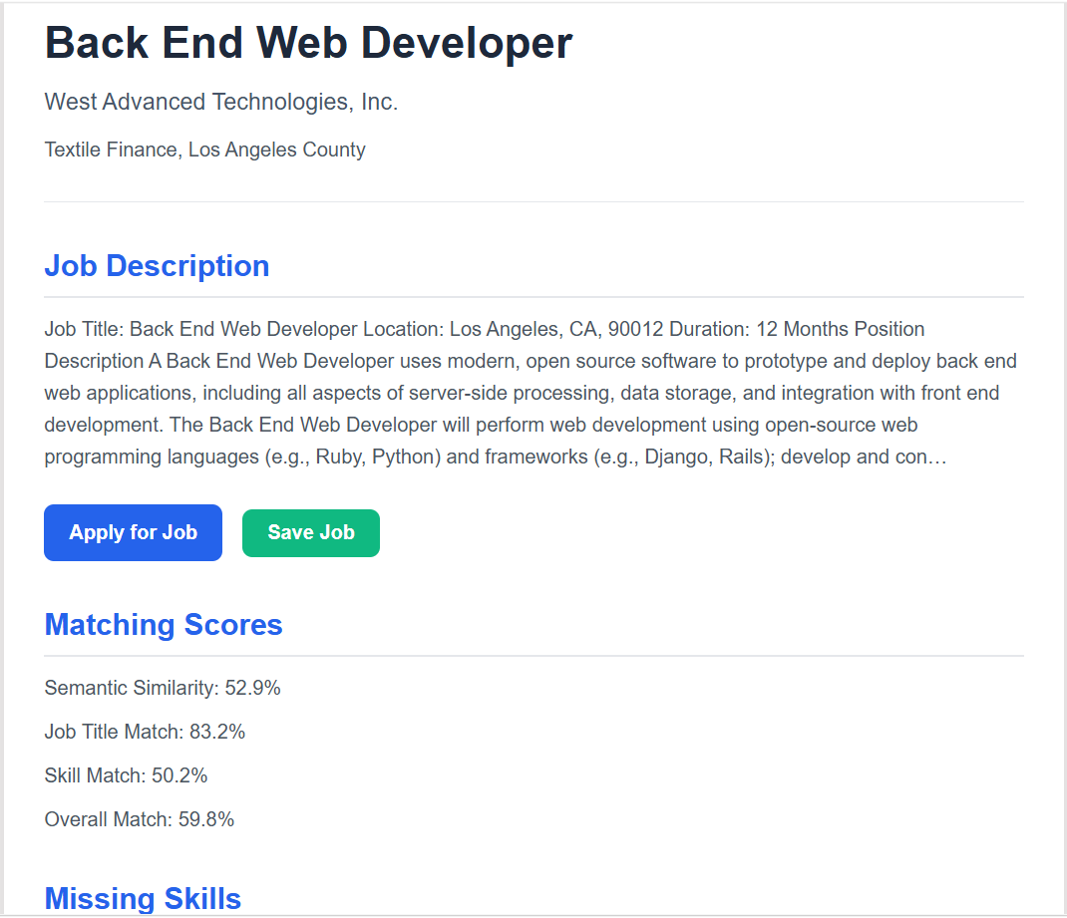
Fig. 6. Matching scores for the specific job.
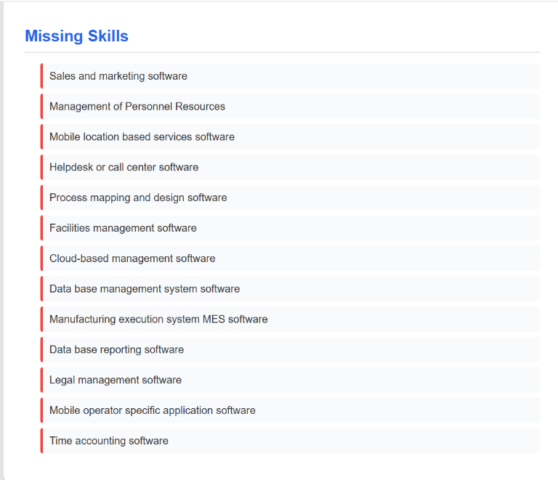
Fig. 7. Missing skills for the specific job.

Experiment/Demonstration Results

Qualitative Analysis
From the recommendations and resumes it was observed that the system was working and was useful in providing job recommendations. The semantic similarity showed that even when the terminology used was different, the system could still capture its meaning and recommend jobs accordingly. An example of this is when the computer science resume was uploaded, I got recommended jobs for web development, software engineer, software development, etc. so the semantic meanings were understood. For the overall similarity scores, they were higher than the semantic similarity scores as they also took into account the job titles and skills, so it was more accurate.

Quantitative Analysis
Sentence-BERT and FAISS ranking computes this score by looking at how semantically similar the user’s resume and 30 of the top ranked job postings are. The standard deviations are around 0.05 which means the job recommendations are mostly consistent with their semantic similarity.

Table I. Semantic Similarity
 | Semantic Similarity
Resume | Low | High | Average | Std Dev
Computer Science | 0.2939 | 0.5369 | 0.4276 | 0.0621
Nursing | 0.3667 | 0.6014 | 0.4770 | 0.0541
Finance | 0.3211 | 0.5194 | 0.4105 | 0.0570
Construction | 0.3877 | 0.5780 | 0.4822 | 0.0508
Psychology | 0.2275 | 0.4830 | 0.3573 | 0.0486

The overall similarity also looks at the top ranked 30 jobs and the user’s resume. The lowest, highest, and average values are higher than the values for semantic similarity. This means that the system was able to find jobs of higher similarity. The standard deviation is lower which means it is more accurate and consistent.
Table II. Overall Similarity
 | Overall Similarity
Resume | Low | High | Average | Std Dev
Computer Science | 0.4657 | 0.6272 | 0.5436 | 0.0403
Nursing | 0.4670 | 0.5526 | 0.5045 | 0.0278
Finance | 0.4381 | 0.6051 | 0.5102 | 0.0485
Construction | 0.5060 | 0.6365 | 0.5587 | 0.0352
Psychology | 0.3499 | 0.4932 | 0.4208 | 0.0369

Five different resumes were taken and the job title and skills similarity to job descriptions were computed. The different resumes include careers such as computer science, nursing, finance, construction, and psychology. The top five job titles that are being predicted come from a dataset in O*Net and when the job titles are extracted, they are used to compare against the job description. The top ten skills are also extracted from the user’s resume and job description to be compared with one another, and the similarity scores are recorded in Tables III-VII.
Table III. Computer Science Resume
Computer Science Resume
Job (O*NET) Title | Similarity | Skill | Similarity
Web Developers | 0.5413 | Web platform development software | 0.5211
Web Administrators | 0.4842 | Programming | 0.4539
Computer Programmers | 0.4662 | Development environment software | 0.4352
Software Developers | 0.4267 | Graphical user interface development software | 0.4213
Computer Science Teachers | 0.4157 | Application server software | 0.4002

Table IV. Nursing Resume
Nursing Resume
Job (O*NET) Title | Similarity | Skill | Similarity
Acute Care Nurse | 0.5332 | Medical software | 0.2871
Critical Care Nurse | 0.5245 | Instructing | 0.1961
Nursing Assistants | 0.4633 | Billing and invoicing software | 0.1946
Clinical Nurse Specialists | 0.4594 | Service Orientation | 0.1858
Registered Nurse | 0.4532 | Contact center software | 0.1858

Table V. Finance Resume
Finance Resume
Job (O*NET) Title | Similarity | Skill | Similarity
Financial Managers | 0.4429 | Management of financial resources | 0.3600
Financial Clerks | 0.4341 | Financial analysis software | 0.3533
Financial Examiners | 0.4214 | Accounting software | 0.3372
Credit Analysts | 0.4210 | Business intelligence and data analysis software | 0.2877
Financial Specialists | 0.4203 | Billing and invoicing software | 0.2673

Table VI. Construction Resume
Construction Resume
Job (O*NET) Title | Similarity | Skill | Similarity
Construction Managers | 0.5423 | Equipment maintenance | 0.3649
Operating Engineers | 0.4829 | Equipment selection | 0.3391
Surveyors | 0.4749 | Project management software | 0.3152
Project Management Specialists | 0.4723 | Materials requirements planning logistics | 0.3028
Helpers, Construction Trades | 0.4667 | Aviation ground support software | 0.2858

Table VII. Psychology Resume
Psychology Resume
Job (O*NET) Title | Similarity | Skill | Similarity
Mental Health Counselors | 0.4358 | Instructing | 0.2417
Substance Abuse and Behavioral Disorder Counselors | 0.4268 | Social perceptiveness | 0.1552
Therapists, All Other | 0.4129 | Writing | 0.1531
Psychiatric Aides | 0.4097 | Troubleshooting | 0.1531
Fitness and Wellness Coordinators | 0.4052 | Critical thinking | 0.1441

The overall score considers the semantic similarity, predicted job titles, and extracted skill similarity to come up with an overall score and rank them. The overall similarity score is higher than the semantic similarity score because it includes more factors, having the job titles and skills increases the weighted average.
Table VIII. Overall Score
Resume | Semantic Similarity | Overall Similarity
Computer Science | 0.3548 | 0.4269
Nursing | 0.4834 | 0.5152
Finance | 0.3441 | 0.4566
Construction | 0.4505 | 0.4996
Psychology | 0.3116 | 0.3893
The top five extracted job titles and top ten skills from each of the sample resumes are shown in figures 8-12. The calculated semantic similarity statistics consist of the lowest, highest, average, and standard deviation values. The same goes for the overall similarity statistics, except their values are higher as it uses a hybrid ranking formula.
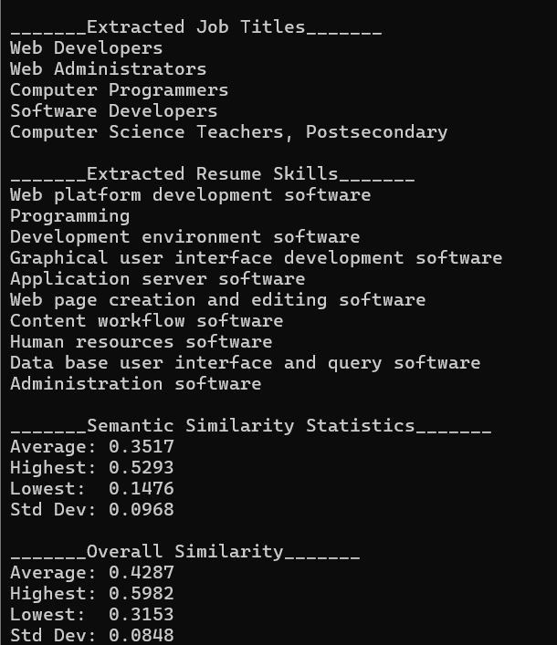
Fig. 8. Computer science resume.

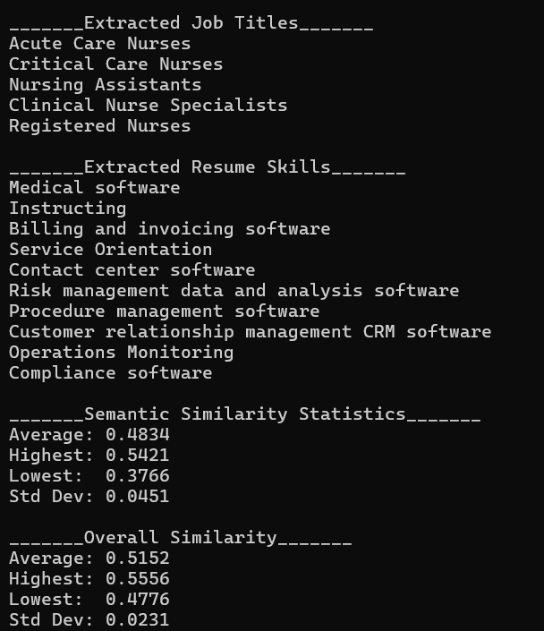
Fig. 9. Nursing resume.

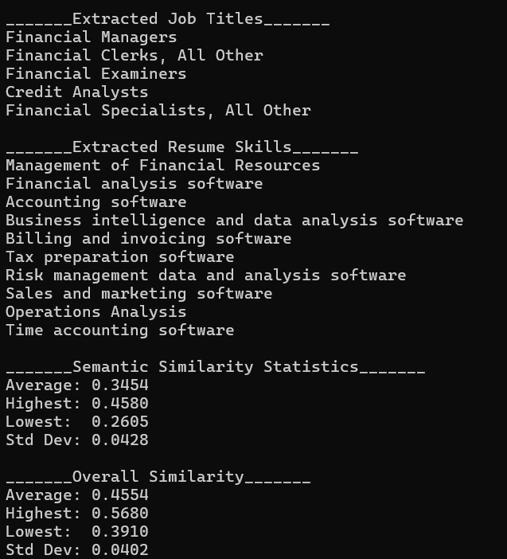
Fig. 10. Finance resume.

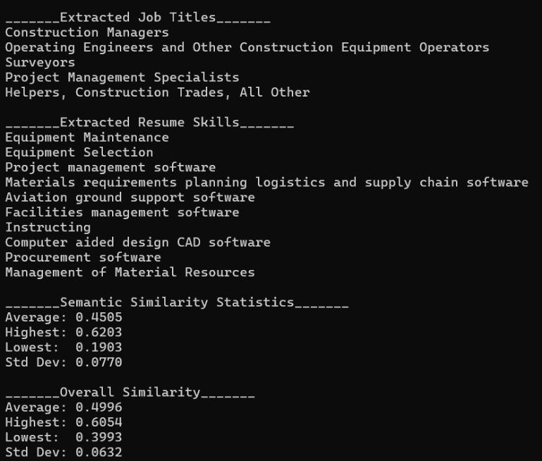
Fig. 11. Construction resume.

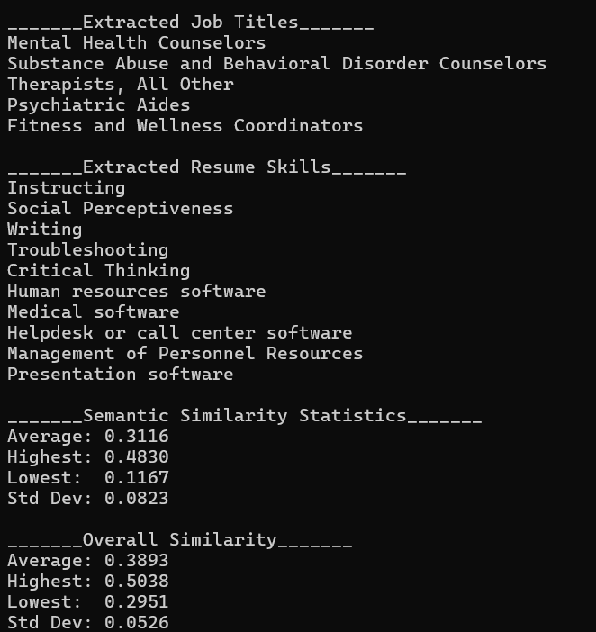
Fig. 12. Psychology resume.

Conclusion
The AI-powered job recommendation system successfully processed uploaded resumes, integrated multiple job APIs, and provided analysis for users to look at. The experiment results show how semantic and overall scores compare, and how jobs are ranked. For future work, filters such as location, salary, date posted, etc. can be added to the job recommendation page to narrow down the results. More personalized recommendations can be given to users on how they can improve their resume for specific job postings.

References
[1] | T. Krantz and A. Jonker, “Cosine Similarity,” Jul. 2025. Accessed: Aug. 07, 2026. [Online]. Available: https://www.ibm.com/think/topics/cosine-similarity
[2] | jazzband, “Djangorestframework-Simplejwt/Rest_Framework_Simplejwt at Master · Jazzband/Djangorestframework-Simplejwt,” GitHub. Accessed: Aug. 08, 2026. [Online]. Available: https://github.com/jazzband/djangorestframework-simplejwt/blob/master/rest_framework_simplejwt
[3] | S. Fazeli, “FAISS: A Quick Tutorial to Efficient Similarity Search,” Medium. Accessed: Aug. 08, 2026. [Online]. Available: https://shayan-fazeli.medium.com/faiss-a-quick-tutorial-to-efficient-similarity-search-595850e08473
[4] | Indeed Editorial Team, “How Does Indeed Work? Using Indeed for Your Job Search,” Jul. 2024. Accessed: Aug. 07, 2026. [Online]. Available: https://www.indeed.com/career-advice/finding-a-job/how-does-indeed-work
[5] | “How to Use Glassdoor to Search for a Job.” Accessed: Aug. 07, 2026. [Online]. Available: https://www.glassdoor.com/blog/guide/how-to-use-glassdoor/
[6] | “Models | Django Documentation,” 2025. Accessed: Aug. 07, 2026. [Online]. Available: https://docs.djangoproject.com/en/6.0/topics/db/models/
[7] | National Center for O*NET Development, “O*NET Database,” Onetcenter.org. Accessed: Aug. 08, 2026. [Online]. Available: https://www.onetcenter.org/database.html#tabular
[8] | “Quickstart - Django REST Framework,” Django-rest-framework.org. Accessed: Aug. 08, 2026. [Online]. Available: https://www.django-rest-framework.org/tutorial/quickstart/#testing-our-api
[9] | “Quickstart — Sentence-Transformers Documentation.” Accessed: Aug. 07, 2026. [Online]. Available: https://www.sbert.net/docs/quickstart.html
[10] | “Rest_Framework_Simplejwt Package — Simple JWT 0.0.Post50+Ga7cb077ea Documentation,” Readthedocs.io. Accessed: Aug. 08, 2026. [Online]. Available: https://django-rest-framework-simplejwt.readthedocs.io/en/latest/rest_framework_simplejwt.html#rest_framework_simplejwt.authentication.JWTTokenUserAuthentication
[11] | “Search Ads,” Adzuna.com. Accessed: Aug. 08, 2026. [Online]. Available: https://developer.adzuna.com/docs/search
[12] | “Search for Jobs on LinkedIn.” Accessed: Aug. 07, 2026. [Online]. Available: https://www.linkedin.com/help/linkedin/answer/a511260
[13] | Hugging Face, “sentence-transformers/all-MiniLM-L6-v2 · Hugging Face.” Accessed: Aug. 07, 2026. [Online]. Available: https://huggingface.co/sentence-transformers/all-MiniLM-L6-v2
[14] | “SentenceTransformers Documentation — Sentence-Transformers Documentation.” Accessed: Aug. 07, 2026. [Online]. Available: https://sbert.net/
[15] | J. Noel, “Vector Search in Practice: Using Embeddings With FAISS and Chroma,” DEV Community. Accessed: Aug. 08, 2026. [Online]. Available: https://dev.to/josmel/vector-search-in-practice-using-embeddings-with-faiss-and-chroma-1ac4
[16] | “Views - Django REST Framework,” Django-rest-framework.org. Accessed: Aug. 08, 2026. [Online]. Available: https://www.django-rest-framework.org/api-guide/views/#api_view
[17] | GeeksforGeeks, “What Is FAISS?,” Jun. 2025. Accessed: Aug. 07, 2026. [Online]. Available: https://www.geeksforgeeks.org/data-science/what-is-faiss/

